Dear Students and Parents,

I have the exciting opportunity to once again offer Paipo (Boogie Board) and Surfboard building through Rye Junior High School’s Wave Riding Project (https://sites.google.com/a/sau50.org/wave-riding/)! This is an amazing opportunity in which participants learn wood working craftsmanship, collaboration skills, engineering and design concepts, and build a truly beautiful board that will provide years of enjoyment and healthy activity! As the project has limited space available, the 8th graders are being given “first dibs” to participate in this project. This letter is meant to serve as an invitation for your child to participate and to provide information about time, cost, and commitment required for the project!

Thanks to a generous discount offered by Grain Surfboards as well as a wonderful grant received from the Rye Education Foundation (REF), we are able to offer these boards at substantially discounted prices. The basic details are provided below. If you have further questions, please do not hesitate to contact me!

Time and Commitment:
Building a Paipo or Surfboard takes time, patience, and commitment. In order to complete the project in a timely manner, students must commit to being present at each building session time. Missing sessions will jeopardize the student’s ability to complete the project.

Building sessions will take place during three time frames; it is expected that students attend ALL SESSIONS EACH WEEK! The first time frame is during WIN (What I Need) and Advisory blocks. Participating students will be scheduled to be in the Wave Riding group during each WIN/Advisory block that is offered. Students are expected to arrive promptly and prepared to work.

Building sessions will also take place one day after school each week until 5pm (potentially Friday afternoons as Friday’s typically have the fewest student conflicts. The exact day will be selected by the group after considering participant schedules). Students are expected to be at this session each week. This requirement must be considered as students and families plan sports and other after school activities and weekend trips. It is expected that students be at each session until 5pm. Missing sessions will jeopardize the student’s ability to complete the project.

Finally, one building session will take place on a Saturday between 9am and 3pm. The specific Saturday will depend on student progress, but it will occur early in the project as a longer time stretch will be needed to complete some of the early tasks.

The Paipo boards will be built first. These boards should be able to be finished within a three week time frame (no Saturday required). The surfboards will begin once the Paipo’s have finished; we may be able to overlap the start/finish time of the two groups.
Cost:
Thanks to a generous grant from The Rye Education Foundation (REF), we are able to offer each student a $203 credit towards the cost of his or her chosen board.

Paipo Boards: (Leash is NOT included; students will have to purchase their own leash)
Cost of board materials and leash cup: $178
Cost of leash: $25
Total cost: $203
Discounted credit from REF grant: $203
Final cost to student: $0
That’s right! There is no charge to students for building a Paipo board!

Surfboards:
There are four options of surfboards to choose from: The Pandan, The Steamer, The Waterlog, and a prototype model (yet to be named!).
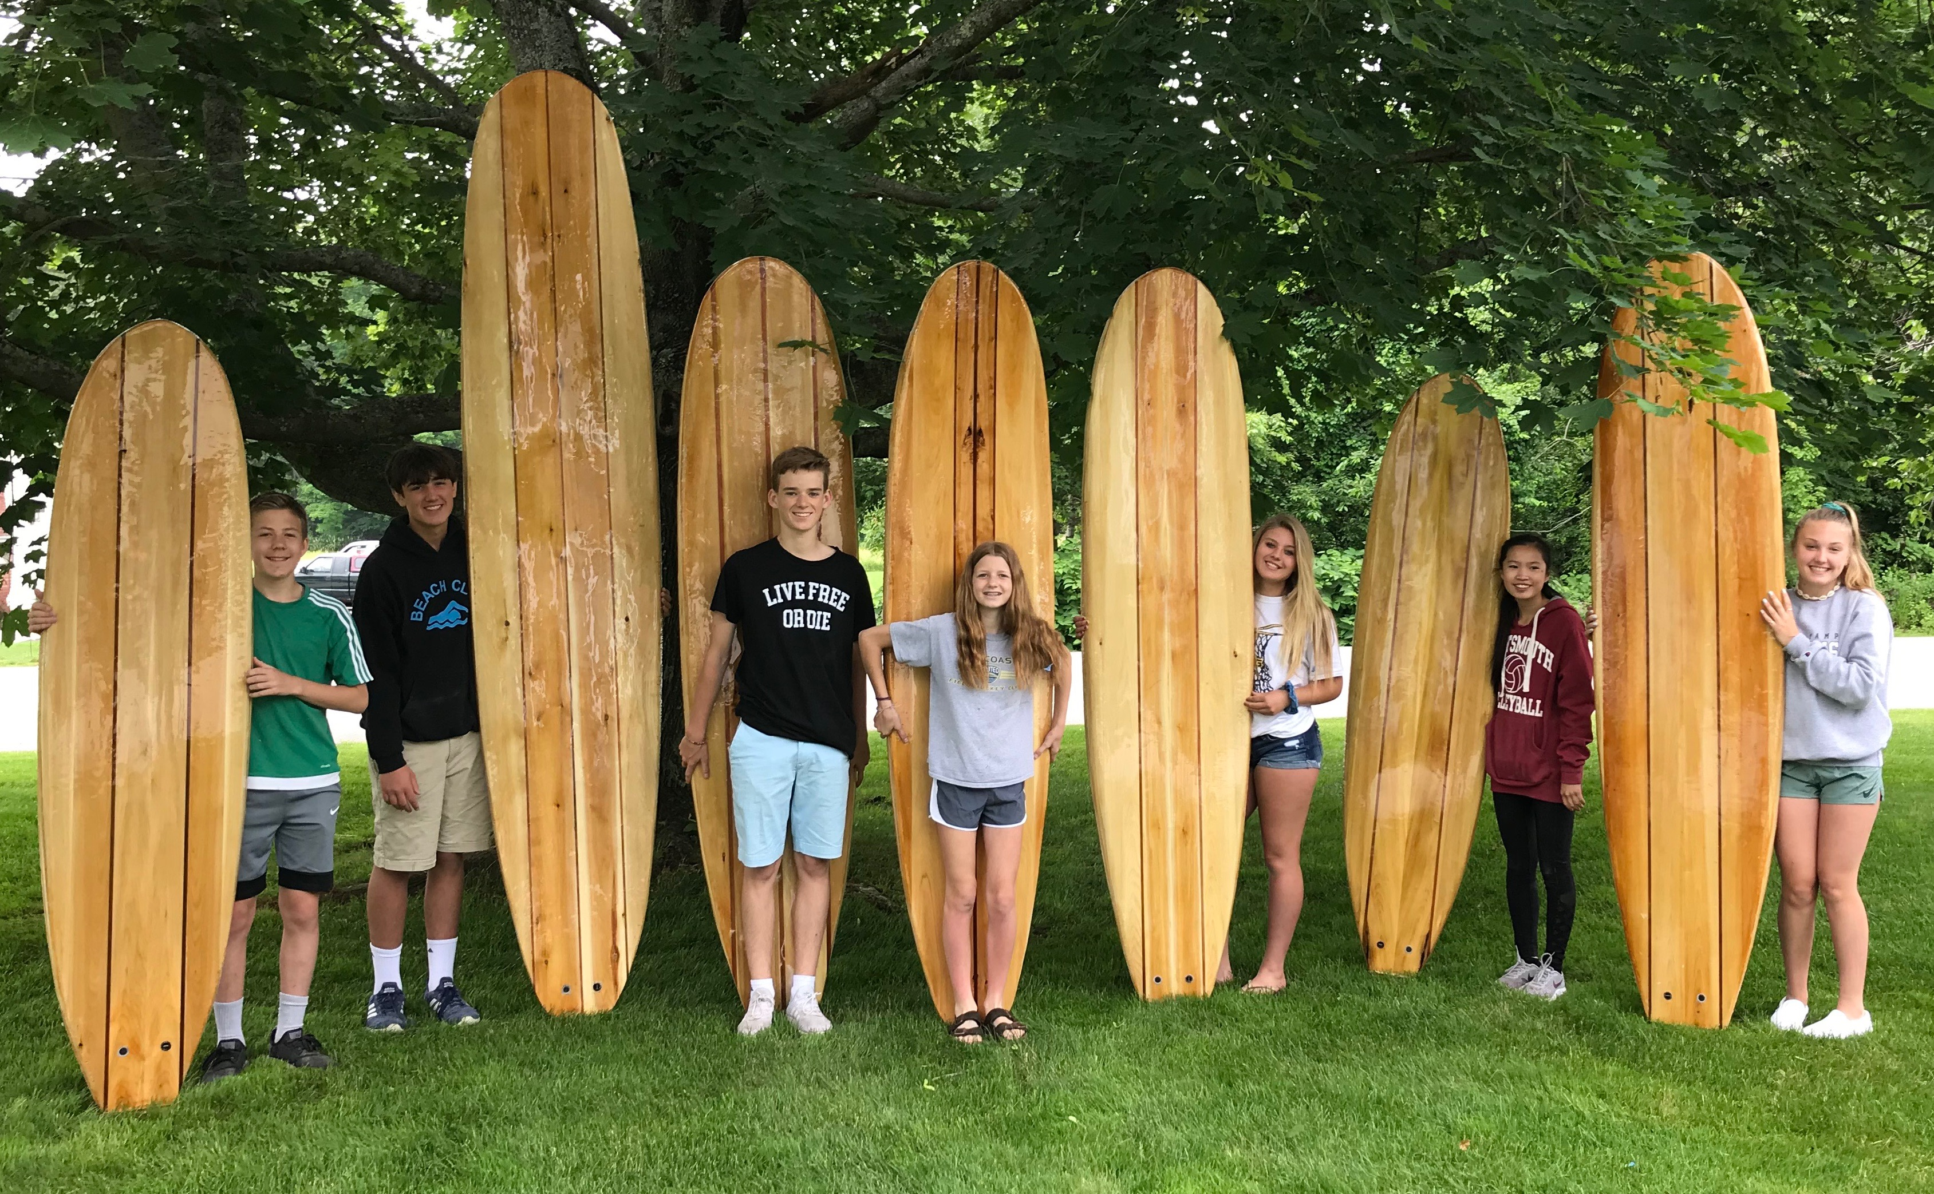
Boards from left to right: Pandan, Waterlog, Steamer, Steamer, Steamer, Pandan, Steamer; not pictured is the prototype model.

Surfboards kits can be ordered with, or without “stringers.” Stringers are accent color stripes. Students may opt to include 1 or two stringers (there is a $25 additional cost for adding stringers).

The Pandan:
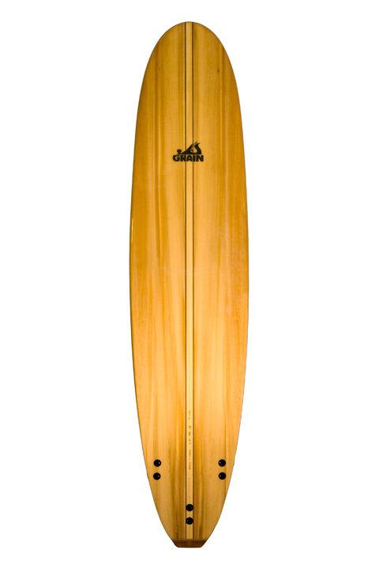
The Pandan is a 7’ board.

Cost of board materials, leash cup, and fin hardware: $690
Cost of fins: $75-$100 (*$75 price is used to calculate total cost)
Cost of leash: $25
Total Cost: $790* (includes $75 fin option)
Discounted credit from REF grant: $203
Final cost to student: $587 (regular pricing: $955)

Add one to two “stringers”: additional $25 ($612)
Add higher cost fin: additional $25 ($637)

The Steamer:
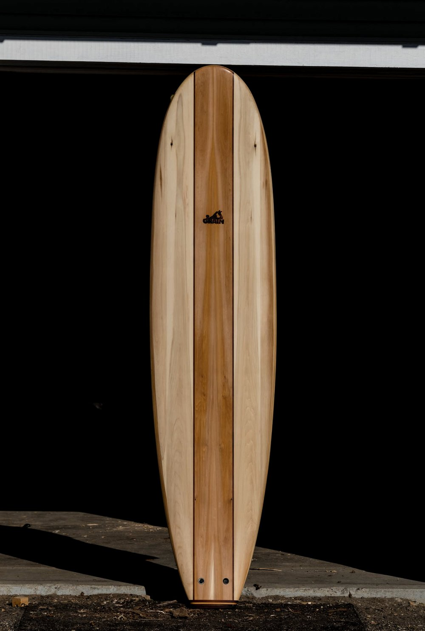
The Steamer is an 8’ board.

Cost of board materials, leash cup, and fin hardware: $710
Cost of fins: $75-$100 (*$75 price is used to calculate total cost)
Cost of leash: $25
Total Cost: $810* (includes $75 fin option)
Discounted credit from REF grant: $203
Final cost to student: $607 (regular pricing: $980)

Add one to two “stringers”: additional $25 ($632)
Add higher cost fin: additional $25 ($657)

The Waterlog:
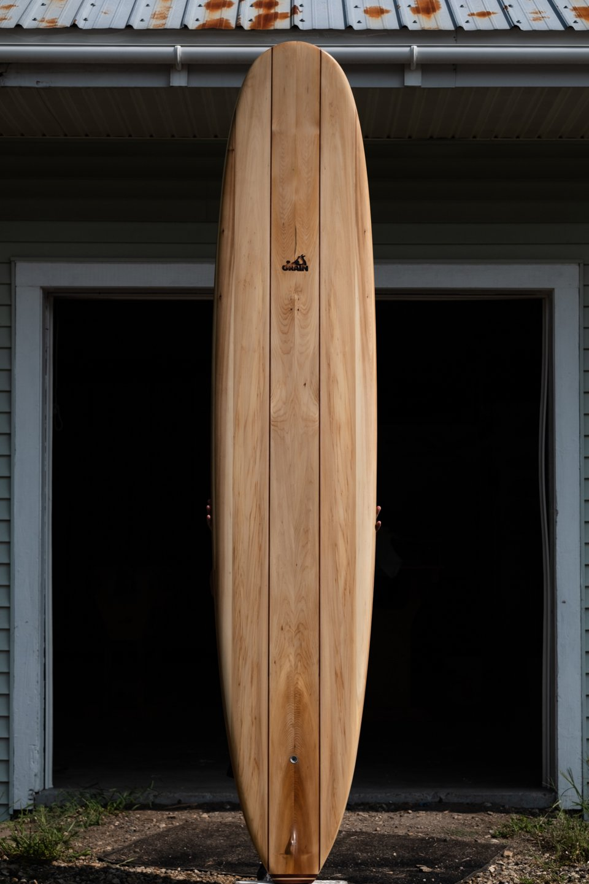
The Waterlog is a 10’ board.

Cost of board materials, leash cup, and fin hardware: $790
Cost of fins: $75-$100 (*$75 price is used to calculate total cost)
Cost of leash: $25
Total Cost: $890* (includes $75 fin option)
Discounted credit from REF grant: $203
Final cost to student: $687 (regular pricing: $1,080)

Add one to two “stringers”: additional $25 ($712)
Add higher cost fin: additional $25 ($737)

The fourth board is a prototype board (less “rail work” involved - faster build)
Cost of board materials, leash plug, fin hardware: $650-$800 depending on length
Cost of fins: $75
Cost of leash: $25
Total Cost: $750-$900 depending on length selected
Discounted credit from REF grant: $203
Final cost to student: $547-$697 depending on length selected

Add one to two “stringers”: additional $25 ($572-$722)
Add higher cost fin: additional $25 ($597-$747)

___________________________________________________________________________________________

If you would like your son/daughter to participate in the Wave Riding Project, please sign below and return this form to Dr. Ellwood. An indication of intent to participate (signing and returning this form) is due by 12/20/19. A 50% deposit is due by 1/8/20. The remaining balance will be due by 1/22/20.
**No surfboard materials will be purchased until balance is paid in full.**

Intent to participate:

Student Name: _____________________________________________

Student Signature: _________________________________________
(**signature indicates commitment to being present at all work sessions!)**

Parent Name: _____________________________________________

Parent Signature: _________________________________________
(**signature indicates commitment to support student being at all work sessions!)**

Please check one:
My son/daughter would like to build a:
_______ Paipo (boogie board)
_______ Pandan
_______ Steamer
_______ Waterlog
_______ Prototype Board (less time commitment)

**Scholarship money may be available to help families needing financial assistance!**

Deposit/payment amount enclosed: $______________
rellwood@sau50.org

